Question 1 :

Navigate through the file system and list all the files in /etc that starts with letter s.

Solution :

ls /etc/s*

Question 2 :

Use commands to check system uptime, memory usage, cpu load, and disk space.

Solution :

uptime && free -h && df -h -> This will show uptime, memory usage, and disk space in one command.

CPU load : top

Question 3 :

Create a new user account and set a secure password for it.

Solution :

sudo useradd -m newuser

sudo passwd newuser

Question 4 :

Change permissions and ownership of a file and verify the changes.

Solution :

Touch testfile.txt

Chmod 744 testfile.txt

Ls -l textfile.txt

Sudo chown yousef:developers testfile.txt

Ls -l testfile.txt

Question 5 :

Compress and decompress files using gzip and tar.

Solution :

echo "This is a sample file for compression." > file.txt

gzip file.txt

gunzip file.txt.gz

tar -czvf archive.tar.gz file.txt

tar -xzvf archive.tar.gz

Question 6 :

Monitor system logs and extract lines containing the word error into a separate file.

Solution :

cat << EOF > testlog.log

Info: System started successfully.

Warning: Disk space low.

Error: Failed to load module.

error: Network timeout occurred.

Debug: Checking configuration.

EOF

grep -i "error" testlog.log > errors.log

cat errors.log

Question 7 :

Schedule a daily job using cron to run a simple script at 5 pm

Solution :

nano /home/yousef/myscript.sh

#!/bin/bash

echo "Hello! This script ran at $(date)" >> /home/yousef/script_log.txt

chmod +x /home/yousef/myscript.sh

/home/yousef/myscript.sh

cat /home/yousef/script_log.txt

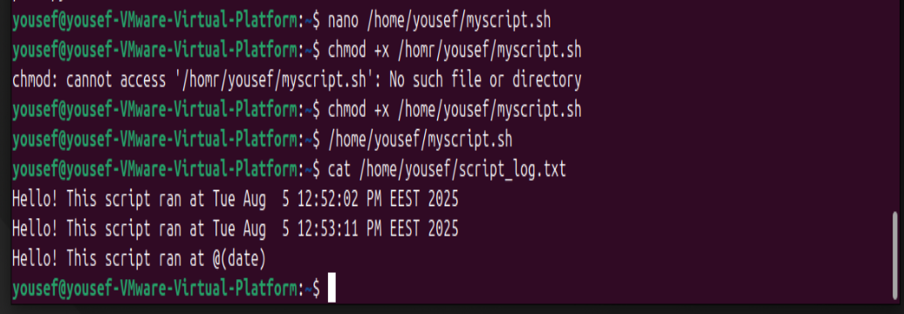

Question 8 :

Set a static ip address using the appropriate linux network configuration files.

Solution :

ls /etc/netplan/

network:

version: 2

ethernets:

ens33:

dhcp4: no

addresses:

- 192.168.1.100/24

gateway4: 192.168.1.1

nameservers:

addresses:

- 8.8.8.8

- 8.8.4.4

sudo netplan apply

ip a

Question 9 :

Install and remove a software package using apt.

Solution :

sudo apt update

sudo apt install htop

htop

sudo apt remove htop

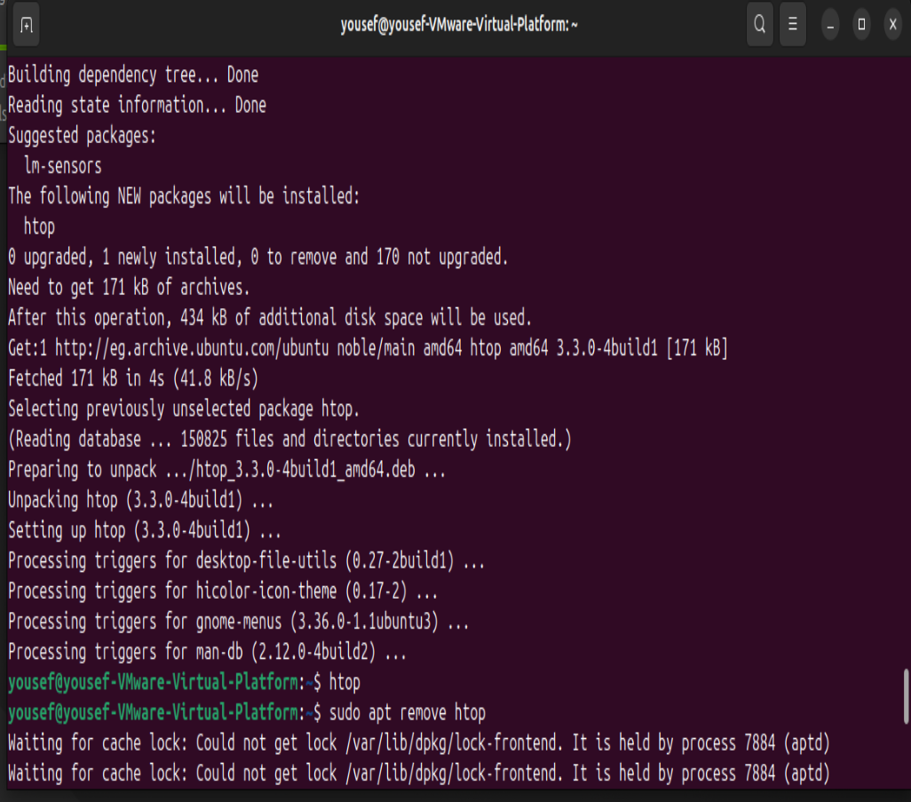

Question 10 :

Check the status of a service(like ssh or nginx) and restart it if inactive.

Solution :

systemctl status ssh

sudo systemctl restart ssh

